
CSA1601 – Data Warehousing and Data Mining
KARANYA S
192421309
Assignment 3 – CO3: Classification and Prediction
Total Marks: 50
Q1. Decision Tree Induction: Choosing the Splitting Attribute (6 Marks)
1.1 Identify the attributes
The given dataset contains 12 loan records.
- Class attribute: Approved (Yes/No)
- Candidate splitting attributes:
  - Income
  - Credit History
  - Employment
Stopping conditions:
- Stop when all records belong to the same class.
- Stop when no attributes remain.
- Stop when further splitting does not improve classification.
- Stop when the minimum number of records in a leaf is reached.
Splitting criterion: Information Gain using Entropy.
Pruning approach: Reduced-error pruning or J48 confidence-based pruning.
1.2 Calculate the entropy of the complete dataset
Total records = 12
Approved = Yes: 4
Approved = No: 8
Formula:
\[ H(S)=-p_+\log_2p_+-p_-\log_2p_- \]
\[ =-\frac4{12}\log_2\frac4{12} -\frac8{12}\log_2\frac8{12} \]
\[ \boxed{H(S)=0.9183\text{?}} \]
Correction: evaluating the expression gives:
\[ \boxed{H(S)=0.9183} \]
1.3 Calculate information gain
Formula:
\[ IG(A)=H(S)-H(S|A) \]
The attribute calculations are:
Attribute | Weighted entropy | Information gain
Income | 0.8113 | 0.1686
Credit History | 0.7842 | 0.1957
Employment | 0.9591 | 0.0207
Root attribute: Credit History
Credit History has the highest information gain and is selected as the root node.
1.4 Gain ratio and Gini index
Gain ratio:
\[ GR(A)=\frac{IG(A)}{SplitInfo(A)} \]
For Credit History, both branches contain six records.
\[ SplitInfo=-2(0.5\log_2 0.5)=1 \]
\[ GR=\frac{0.1957}{1}=0.1957 \]
Gini index:
\[ Gini(S)=1-\sum p_i^2 \]
The Gini gain values are:
Attribute | Gini gain
Income | 0.1111
Credit History | 0.1250
Employment | 0.0139
Both Information Gain and Gini select Credit History.
1.5 Construct the decision tree
The tree uses Credit History as the root, followed by Employment and Income where required.
1.6 Final decision tree
Decision Tree (assumptions, advantages, disadvantages, applications) | by Ttcbest | Medium
medium.com
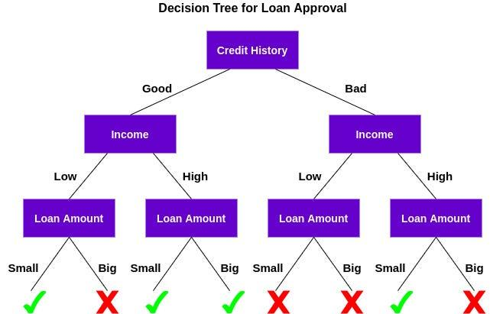
Decision rules:
- If Credit History = Good and Employment = Salaried → Approved = Yes.
- If Credit History = Good, Employment = Self-employed and Income = High → Yes.
- If Credit History = Good, Employment = Self-employed and Income = Medium or Low → No.
- If Credit History = Poor and Employment = Salaried → No.
- If Credit History = Poor, Employment = Self-employed and Income = High → Yes.
- If Credit History = Poor, Employment = Self-employed and Income = Medium or Low → No.
1.7 Effect of attributes with many distinct values
An attribute such as Customer ID may contain a unique value for every record.
- It creates too many branches.
- It may perfectly classify training records.
- It cannot generalise to new customers.
- It causes overfitting.
- Removing ID attributes and applying pruning can reduce the problem.
1.8 Weka validation – Student B
Procedure:
- Open Weka Explorer.
- Load the loan dataset in CSV or ARFF format.
- Select Classify.
- Choose trees → J48.
- Select 10-fold cross-validation.
- Run the classifier.
- Repeat using different confidence factors and minimum leaf sizes.
Suggested settings:
Experiment | Confidence factor | Minimum instances
1 | 0.25 | 1
2 | 0.10 | 1
3 | 0.05 | 2
4 | 0.05 | 3
Overfitting: A model learns the training data too closely, including noise. It performs well on training data but poorly on unseen data.
Reducing the confidence factor and increasing minimum leaf size generally produce simpler trees.
Conclusion: Credit History is the best root attribute based on information gain. Pruning and cross-validation help improve generalisation.
Q2. Bayesian Classification and the Cost of Assumptions (6 Marks)
2.1 Naïve Bayes classifier
Naïve Bayes is a probabilistic classification algorithm based on Bayes' theorem.
Formula:
\[ P(C|X)=\frac{P(X|C)P(C)}{P(X)} \]
Given:
- Income = Low
- Credit History = Good
- Employment = Self-employed
2.2 Calculate prior probabilities
Total records = 12
Approved Yes = 5
Approved No = 7
\[ P(Yes)=\frac5{12}=0.4167 \]
\[ P(No)=\frac7{12}=0.5833 \]
2.3 Calculate conditional probabilities
Attribute | Approved Yes | Approved No
Income = Low | 1/5 | 3/7
Credit = Good | 4/5 | 2/7
Self-employed | 2/5 | 4/7
2.4 Calculate posterior probabilities
For Approved = Yes:
\[ P(X|Yes)P(Yes) \]
\[ =\frac15\times\frac45\times\frac25\times\frac5{12} \]
\[ =0.02667 \]
For Approved = No:
\[ P(X|No)P(No) \]
\[ =\frac37\times\frac27\times\frac47\times\frac7{12} \]
\[ =0.02332 \]
Therefore:
\[ P(Yes|X)>P(No|X) \]
Predicted class: Approved = Yes
2.5 Laplace correction
Laplace correction is used to avoid zero probabilities.
Formula:
\[ P(x_i|C)=\frac{count(x_i,C)+1}{count(C)+k} \]
Where:
- \(k\) = number of possible values.
- 1 is added to every category count.
For example, if a feature has zero occurrences in a class containing four records and has three possible values:
\[ P=\frac{0+1}{4+3}=\frac17 \]
This prevents the entire posterior score from becoming zero.
For the given applicant, applying add-one smoothing to all three attributes gives:
\[ Score(Yes)=\frac5{12}\times\frac2{8} \times\frac5{7}\times\frac3{7} \]
\[ =0.02232 \]
\[ Score(No)=\frac7{12}\times\frac4{10} \times\frac3{9}\times\frac5{9} \]
\[ =0.04321 \]
After normalisation:
\[ P(Yes|X)\approx0.3406 \]
\[ P(No|X)\approx0.6594 \]
Therefore, with Laplace smoothing, the predicted class changes to Approved = No.
2.6 Weka verification – Student B
Steps:
- Open Weka Explorer.
- Load the loan dataset.
- Select Classify.
- Choose bayes → NaiveBayes.
- Select 10-fold cross-validation.
- Run the classifier.
- Record the predicted probabilities and confusion matrix.
2.7 Correlated attributes
Naïve Bayes assumes that all attributes are conditionally independent given the class.
Example:
- Monthly income
- Annual income
These two attributes are strongly correlated.
When correlated attributes are used, the same information may be counted multiple times.
Comparison experiment:
Create a synthetic dataset with correlated attributes and compare Naïve Bayes with J48.
Model | Accuracy | Recall | Precision
Naïve Bayes | To be measured | To be measured | To be measured
J48 | To be measured | To be measured | To be measured
Naïve Bayes can still provide useful class rankings even when independence is violated because the relative scores may preserve useful ordering.
2.8 Joint conclusion
Prefer Naïve Bayes when:
- Fast classification is required.
- The dataset has many features.
- Training data are limited.
- Probabilistic predictions are useful.
Prefer Decision Trees when:
- Interpretability is important.
- Relationships between attributes are complex.
- Decision paths must be explained.
Conclusion: Naïve Bayes is simple and efficient, but its independence assumption can reduce probability accuracy when attributes are strongly correlated.
Q3. Rule-Based and Associative Classification (7 Marks)
3.1 Rule-based classification
Rule-based classification represents knowledge using IF–THEN statements.
General format:
\[ IF\ condition\ THEN\ class \]
Example:
IF Credit History = Good AND Employment = Salaried
THEN Approved = Yes.
3.2 Convert the decision tree into rules
Rule | IF condition | THEN
R1 | Credit=Good AND Employment=Salaried | Yes
R2 | Credit=Good AND Employment=Self-employed AND Income=High | Yes
R3 | Credit=Good AND Employment=Self-employed AND Income=Medium/Low | No
R4 | Credit=Poor AND Employment=Salaried | No
R5 | Credit=Poor AND Employment=Self-employed AND Income=High | Yes
R6 | Credit=Poor AND Employment=Self-employed AND Income=Medium/Low | No
3.3 Coverage and accuracy
Coverage:
\[ Coverage=\frac{\text{Number of records covered}}{\text{Total records}} \]
Accuracy:
\[ Accuracy=\frac{\text{Correctly classified records}}{\text{Records covered}} \]
Rule | Covered records | Correct | Accuracy
R1 | 3 | 3 | 100%
R2 | 1 | 1 | 100%
R3 | 2 | 2 | 100%
R4 | 3 | 3 | 100%
R5 | 1 | 1 | 100%
R6 | 2 | 2 | 100%
All rules cover the 12 records.
3.4 Rule conflict resolution
Rule conflict occurs when two or more rules predict different classes for the same input.
Methods:
- Rule ordering – apply the first matching rule.
- Size ordering – prefer the more specific rule.
- Accuracy ordering – prefer the rule with higher accuracy.
- Default rule – assign a default class when no rule matches.
Example:
- Rule 1: Credit = Good → Yes.
- Rule 2: Credit = Good AND Employment = Salaried → Yes.
The more specific rule can be given priority.
3.5 Sequential covering
Sequential covering is a method of learning rules one at a time.
Steps:
- Select positive training examples.
- Generate a rule covering positive examples.
- Evaluate its accuracy.
- Add the rule to the rule set.
- Remove or mark the covered positive examples.
- Repeat until the stopping condition is reached.
3.6 Associative classification
Associative classification uses association rules to predict class labels.
General form:
\[ X\rightarrow Class \]
Two important measures are:
Support:
\[ Support=\frac{\text{Records containing both antecedent and class}}{\text{Total records}} \]
Confidence:
\[ Confidence=\frac{\text{Records satisfying antecedent and class}}{\text{Records satisfying antecedent}} \]
Given:
- Minimum support = 25%
- Minimum confidence = 70%
For the rule:
Credit = Good AND Employment = Salaried → Approved = Yes
Support:
\[ =\frac3{12}\times100=25\% \]
Confidence:
\[ =\frac33\times100=100\% \]
Rule satisfies both thresholds
This rule predicts Approved = Yes.
3.7 JRip/PART in Weka – Student B
Steps:
- Open Weka Explorer.
- Load the credit-g dataset.
- Select Classify.
- Choose rules → JRip or rules → PART.
- Select 10-fold cross-validation.
- Execute the algorithm.
- Record the rules, accuracy and confusion matrix.
Difference between J48 and JRip:
J48 | JRip
Builds a decision tree | Learns an ordered rule set
Uses tree branches | Uses IF–THEN rules
Hierarchical structure | Sequential structure
Can be converted into rules | Directly produces rules
3.8 Joint design question
For a loan officer who must explain every rejection, a decision tree or ordered rule list is recommended.
Reasons:
- Easy to understand.
- Provides clear rejection reasons.
- Supports transparent decisions.
- Makes auditing easier.
- Helps customers understand the decision.
Conclusion: Rule-based classification provides understandable decisions, while associative classification discovers frequent relationships between attributes and class labels.
Q4. Backpropagation: What Does the Network Learn? (7 Marks)
4.1 Given values
- Inputs: \(x_1=1,\ x_2=0\)
- Target: \(t=1\)
- Learning rate: \(\eta=0.9\)
- Hidden units: 2
- Output units: 1
Initial weights:
Connection | Weight
x1 → h1 | 0.2
x2 → h1 | 0.4
x1 → h2 | -0.3
x2 → h2 | 0.1
h1 → output | -0.3
h2 → output | -0.2
Biases: h1 = -0.4, h2 = 0.2, output = 0.1.
4.2 Network architecture
Understanding Feedforward Neural Networks
carbonati.github.io
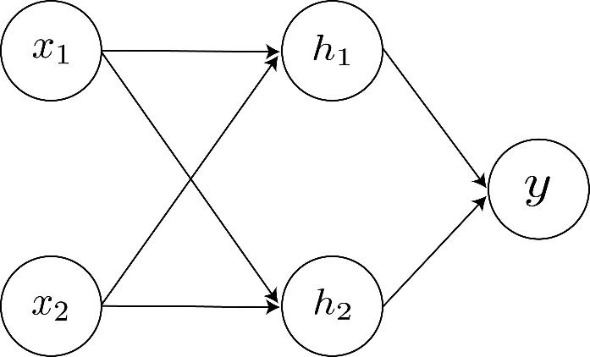
4.3 Forward propagation
Sigmoid activation:
\[ f(x)=\frac1{1+e^{-x}} \]
Hidden unit h1:
\[ Net_{h1}=(1)(0.2)+(0)(0.4)-0.4 \]
\[ =-0.2 \]
\[ h1=\frac1{1+e^{0.2}} \]
\[ \boxed{h1=0.450166} \]
Hidden unit h2:
\[ Net_{h2}=(1)(-0.3)+(0)(0.1)+0.2 \]
\[ =-0.1 \]
\[ \boxed{h2=0.475021} \]
Output unit:
\[ Net_o=(-0.3)(0.450166)+(-0.2)(0.475021)+0.1 \]
\[ =-0.130054 \]
\[ o=\frac1{1+e^{0.130054}} \]
\[ \boxed{o=0.467532} \]
4.4 Calculate error terms
Output delta:
\[ \delta_o=(t-o)o(1-o) \]
\[ =(1-0.467532)(0.467532)(0.532468) \]
\[ \boxed{\delta_o=0.132556} \]
Hidden unit h1:
\[ \delta_{h1}=h1(1-h1)w_{h1,o}\delta_o \]
\[ \boxed{\delta_{h1}=-0.009843} \]
Hidden unit h2:
\[ \delta_{h2}=h2(1-h2)w_{h2,o}\delta_o \]
\[ \boxed{\delta_{h2}=-0.006611} \]
4.5 Update weights and biases
Formula:
\[ w_{new}=w_{old}+\eta\delta x \]
Parameter | Initial | Updated
x1 → h1 | 0.200000 | 0.191141
x2 → h1 | 0.400000 | 0.400000
x1 → h2 | -0.300000 | -0.305950
x2 → h2 | 0.100000 | 0.100000
h1 → output | -0.300000 | -0.246295
h2 → output | -0.200000 | -0.143330
Bias h1 | -0.400000 | -0.408859
Bias h2 | 0.200000 | 0.194049
Bias output | 0.100000 | 0.219300
4.6 Recalculate output
After updating weights:
\[ h1\approx0.445785 \]
\[ h2\approx0.472054 \]
\[ \boxed{o\approx0.510460} \]
Initial error:
\[ E=\frac12(t-o)^2 \]
\[ E_{initial}\approx0.141761 \]
Updated error:
\[ E_{new}\approx0.119825 \]
Error decreased
Therefore, the network learned successfully in this iteration.
4.7 Why are weights initialised with small random values?
- To break symmetry between hidden neurons.
- To allow different neurons to learn different features.
- To avoid identical weight updates.
- To prevent very large initial activations.
- To support stable training.
If all weights are identical, hidden units may learn the same features and reduce network effectiveness.
4.8 Weka MultilayerPerceptron experiment – Student B
Steps:
- Open Weka Explorer.
- Load a real dataset.
- Select Classify.
- Choose functions → MultilayerPerceptron.
- Change learning rate, hidden units and epochs.
- Run 10-fold cross-validation.
- Record training accuracy, test accuracy and runtime.
Suggested experiment settings:
Experiment | Learning rate | Hidden units | Epochs
1 | 0.1 | 2 | 100
2 | 0.3 | 5 | 100
3 | 0.9 | 10 | 300
These are suggested configurations, not measured results.
Overfitting: Training accuracy increases while testing accuracy decreases.
Slow training: The network requires many iterations to reach an acceptable result.
Comparison: Neural networks can learn complex patterns but are less interpretable than decision trees.
Conclusion: Backpropagation adjusts weights using output errors to minimise prediction error.
Q5. Support Vector Machines: Margin, Kernels and Scaling (7 Marks)
5.1 Given dataset
Positive class (+1):
\[ (3,3),(4,3),(4,4) \]
Negative class (-1):
\[ (1,1),(1,2),(2,1) \]
An SVM is a supervised learning algorithm that identifies the best separating hyperplane between two classes.
5.2 Maximum-margin separator
A maximum-margin hyperplane separates the two classes while maximising the distance between the nearest points of both classes.
For this dataset, the separating hyperplane is:
\[ w\cdot x+b=0 \]
Choose:
\[ w=(1,1),\quad b=-4.5 \]
Therefore:
\[ \boxed{x_1+x_2-4.5=0} \]
5.3 Support vectors
Support vectors are the data points closest to the separating hyperplane.
The support vectors are:
- Positive: (3,3)
- Negative: (1,2)
- Negative: (2,1)
Файл:SVM margin.png — Викиконспекты
neerc.ifmo.ru
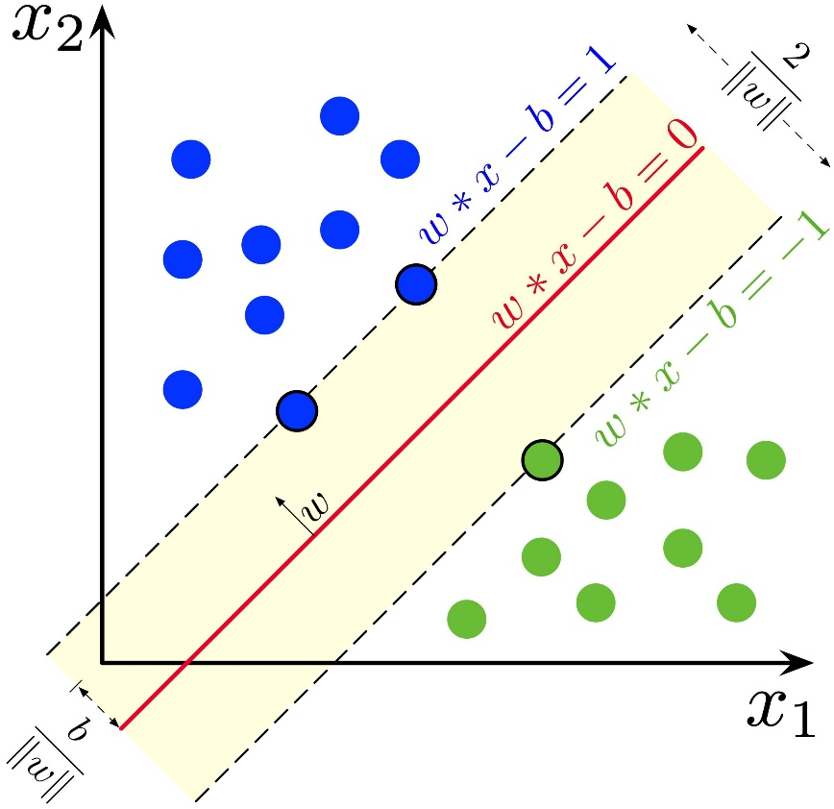
5.4 Calculate margin width
The two margin boundaries are:
\[ x_1+x_2=3 \]
and
\[ x_1+x_2=6 \]
Formula:
\[ Margin=\frac{|c_2-c_1|}{\sqrt{a^2+b^2}} \]
Substitute:
\[ =\frac{|6-3|}{\sqrt{1^2+1^2}} \]
\[ =\frac3{\sqrt2} \]
\[ \boxed{Margin=2.121} \]
5.5 Effect of removing data points
Removing a non-support vector:
- Hyperplane generally remains unchanged.
- Margin remains the same.
- Classification boundary is unaffected.
- Training becomes slightly smaller.
Removing a support vector:
- Hyperplane may change.
- Margin may change.
- Other points may become support vectors.
- Classification performance may be affected.
5.6 Soft margin parameter C
The C parameter controls the penalty for classification errors.
- Large C: Penalises errors heavily and may cause overfitting.
- Small C: Allows more classification errors and provides stronger regularisation.
- It controls the trade-off between margin size and training errors.
5.7 Role of kernels
Kernels help SVM classify nonlinear datasets.
Kernel | Description
Linear | Separates linearly separable data
Polynomial | Handles polynomial relationships
RBF | Handles complex nonlinear relationships
Linear Support Vector Machines Explained | by Mazen Ahmed | Medium
Support Vector Machines Explained Simply | Medium
Why is “Kernel Trick” called a “Trick” ? | by shubhankar Keshri | Medium
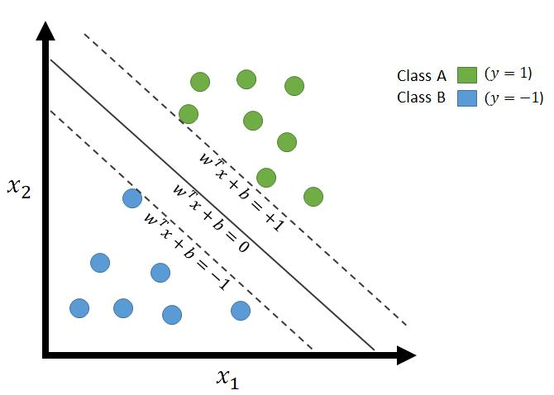
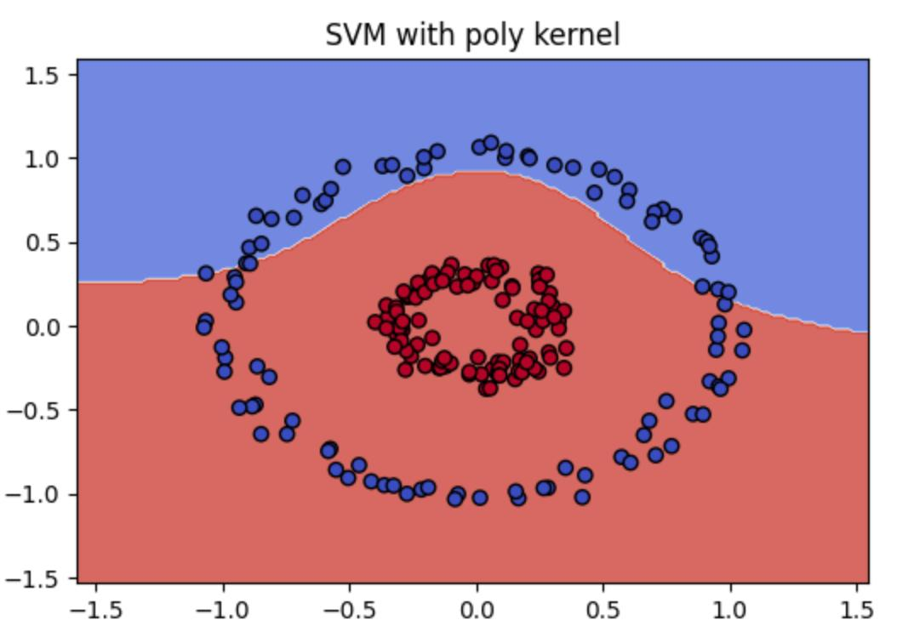
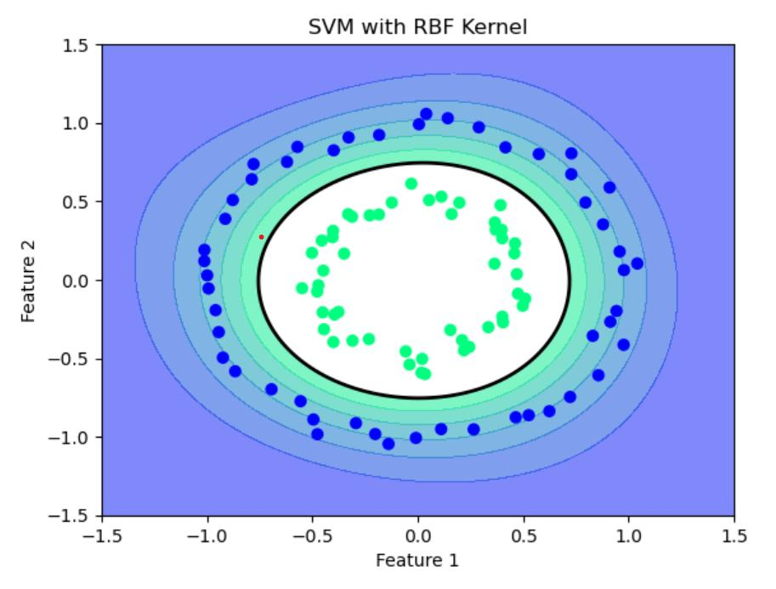
5.8 Weka SMO experiment – Student B
Steps:
- Open Weka Explorer.
- Load a nonlinear dataset such as concentric circles.
- Select Classify.
- Choose functions → SMO.
- Test linear, polynomial and RBF kernels.
- Change C and kernel parameters.
- Repeat after feature scaling.
- Record accuracy, AUC and support-vector count where available.
Suggested experiment table:
Kernel | C | Scaling | Accuracy
Linear | 0.1 | No | To be measured
Polynomial | 1 | No | To be measured
RBF | 1 | No | To be measured
RBF | 1 | Yes | To be measured
5.9 Effect of attribute scaling
Scaling converts attributes into comparable numerical ranges.
Without scaling, attributes with larger numerical values can dominate distance calculations.
With scaling:
- Each feature contributes more appropriately.
- Model performance may improve.
- Training becomes more stable.
- Margin calculations become more meaningful.
5.10 Joint conclusion
SVM is suitable for high-dimensional and nonlinear datasets.
Its practical limitations include:
- Parameter selection is difficult.
- Scaling is important.
- Large datasets may require more computation.
- Model interpretation is difficult.
- Kernel selection affects performance.
Conclusion: SVM provides effective classification by maximising the margin between different classes.
Q6. Evaluating Classifiers and Predictors (7 Marks)
6.1 Given confusion matrix
A fraud-detection classifier is tested on 1,000 transactions.
- TP = 40
- FN = 20
- FP = 30
- TN = 910
Evaluating Classification Models: From Metrics to Curves (Part 1) | by Warda Ul Hasan | Medium
medium.com
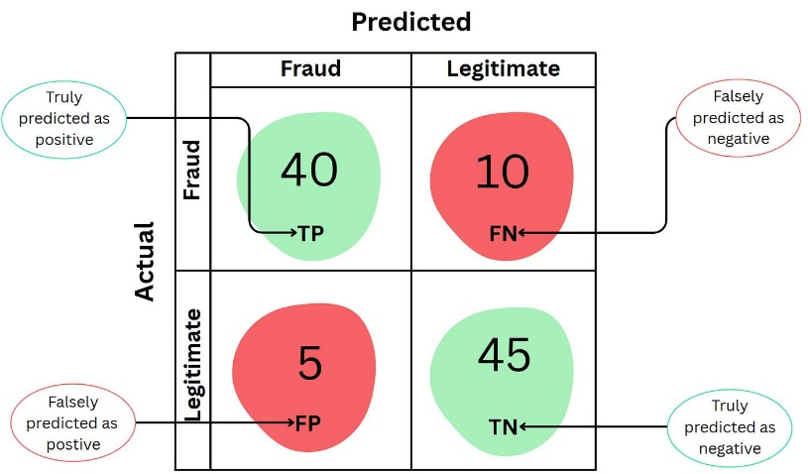
6.2 Calculate classification metrics
1. Accuracy
\[ Accuracy=\frac{TP+TN}{TP+TN+FP+FN} \]
\[ =\frac{40+910}{1000} \]
\[ \boxed{95\%} \]
2. Error rate
\[ Error=\frac{FP+FN}{Total} \]
\[ =\frac{30+20}{1000} \]
\[ \boxed{5\%} \]
3. Sensitivity (Recall)
\[ Recall=\frac{TP}{TP+FN} \]
\[ =\frac{40}{40+20} \]
\[ \boxed{66.67\%} \]
4. Specificity
\[ Specificity=\frac{TN}{TN+FP} \]
\[ =\frac{910}{910+30} \]
\[ \boxed{96.81\%} \]
5. Precision
\[ Precision=\frac{TP}{TP+FP} \]
\[ =\frac{40}{40+30} \]
\[ \boxed{57.14\%} \]
6. F-measure
\[ F1=\frac{2\times Precision\times Recall} {Precision+Recall} \]
\[ \boxed{F1=61.54\%} \]
6.3 Summary of metrics
Metric | Result
Accuracy | 95%
Error rate | 5%
Sensitivity | 66.67%
Specificity | 96.81%
Precision | 57.14%
F-measure | 61.54%
6.4 Class imbalance problem
Class imbalance occurs when one class contains significantly more records than another.
In fraud detection:
- Fraud transactions = 60
- Non-fraud transactions = 940
If a classifier predicts every transaction as non-fraud:
\[ Accuracy=\frac{940}{1000}\times100 \]
\[ \boxed{Accuracy=94\%} \]
However, fraud recall becomes:
\[ Recall=0\% \]
Therefore, accuracy alone cannot determine whether a fraud classifier is effective.
6.5 Regression prediction errors
Given:
Actual values:
\[ 12,15,20,25 \]
Predicted values:
\[ 10,18,19,30 \]
Actual | Predicted | Error | Squared error
12 | 10 | 2 | 4
15 | 18 | -3 | 9
20 | 19 | 1 | 1
25 | 30 | -5 | 25
Mean Absolute Error (MAE)
\[ MAE=\frac{\sum|Actual-Predicted|}{n} \]
\[ =\frac{2+3+1+5}{4} \]
\[ \boxed{MAE=2.75} \]
Mean Squared Error (MSE)
\[ MSE=\frac{\sum(Actual-Predicted)^2}{n} \]
\[ =\frac{4+9+1+25}{4} \]
\[ \boxed{MSE=9.75} \]
Root Mean Squared Error (RMSE)
\[ RMSE=\sqrt{MSE} \]
\[ =\sqrt{9.75} \]
\[ \boxed{RMSE=3.12} \]
6.6 When is RMSE preferred over MAE?
RMSE is preferred when large prediction errors should receive greater penalties.
MAE is preferred when a simple average absolute error is required and extreme errors should not dominate the measure.
6.7 ROC curve
ROC stands for Receiver Operating Characteristic.
It evaluates the performance of a binary classifier at different thresholds.
The graph contains:
- X-axis: False Positive Rate.
- Y-axis: True Positive Rate.
\[ FPR=\frac{FP}{FP+TN} \]
\[ TPR=\frac{TP}{TP+FN} \]
The binormal model for ROC curves - The DO Loop
blogs.sas.com
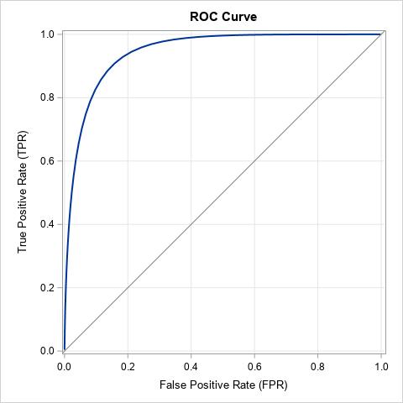
Interpretation:
- The top-left corner represents better classification.
- The diagonal line represents random classification.
- A higher AUC indicates better discrimination.
- ROC helps compare different classification thresholds.
6.8 Estimation methods – Student B
1. Holdout method
The dataset is divided into training and testing datasets.
Example: 80% training and 20% testing.
Advantages:
- Simple.
- Fast.
- Easy to implement.
Disadvantage:
- Results depend on the random split.
2. 10-fold cross-validation
- Divide the dataset into 10 equal folds.
- Train using 9 folds.
- Test using the remaining fold.
- Repeat 10 times.
- Calculate average accuracy.
Advantages:
- Uses data efficiently.
- Provides a more reliable estimate than one split in many settings.
3. Bootstrap (.632)
- Randomly sample records with replacement.
- Train using the bootstrap sample.
- Test using records not selected in that sample.
- Combine apparent and out-of-bag error estimates.
The .632 estimate uses the weighting:
\[ Error_{.632}=0.368(Error_{train})+ 0.632(Error_{test}) \]
This is a simplified presentation of the .632 estimator.
6.9 Comparison of estimation methods
Method | Advantage | Limitation
Holdout | Fast and simple | Split dependent
10-fold CV | Reliable data utilisation | Computationally expensive
Bootstrap | Useful for smaller datasets | May have estimation bias
6.10 Compare J48, Naïve Bayes and SMO
Use Weka Experimenter or Explorer.
- J48: Decision tree classifier.
- Naïve Bayes: Probabilistic classifier.
- SMO: Support Vector Machine implementation.
Compare all three using the same dataset and identical stratified folds.
Record:
- Accuracy
- Precision
- Recall
- ROC-AUC
- Confusion matrix
Repeat holdout using at least five random splits and report the mean and variation.
Model | Accuracy | Recall | ROC-AUC
J48 | To be measured | To be measured | To be measured
Naïve Bayes | To be measured | To be measured | To be measured
SMO | To be measured | To be measured | To be measured
Conclusion: Accuracy alone is insufficient for imbalanced datasets. Cross-validation, precision, recall, F-measure and ROC-AUC provide a better evaluation of classifier performance.
Q7. Design a Classification Solution from First Principles (10 Marks)
Hospital Readmission Prediction System
7.1 Problem identification
A hospital wants to identify patients who may be readmitted within 30 days.
Given:
- Readmission rate = 6%.
- False negative cost = 10 times false positive cost.
- Patient information contains missing values.
- Doctors must understand the reason behind each prediction.
Input attributes:
- Age
- Diagnosis group
- Length of stay
- Number of previous admissions
- Laboratory results
- Discharge medications
Target attribute:
Readmitted within 30 days – Yes/No.
7.2 Stage 1 – Independent design proposals
Student A proposal
Component | Proposed method
Classification | Decision Tree
Missing values | Mean/median and mode imputation
Imbalance | Class weighting
Evaluation | Recall and precision
Explanation | Decision tree paths
Student B proposal
Component | Proposed method
Classification | Rule-based classification
Missing values | Imputation and missing-value indicators
Imbalance | Resampling
Evaluation | ROC-AUC and total cost
Explanation | IF–THEN rules
7.3 Stage 2 – Compare the two designs
Student A | Student B
Easy-to-understand tree | Simple rule-based decisions
Hierarchical structure | Independent rules
Supports visualisation | Supports direct explanation
May overfit | May produce conflicting rules
Final decision: Combine a pruned, cost-sensitive decision tree with an ordered set of explanatory rules.
7.4 Stage 3 – Joint final design
Proposed architecture
Improvements of LACE+ 30-day Readmission Risk Score - Main
luoluo-l.github.io
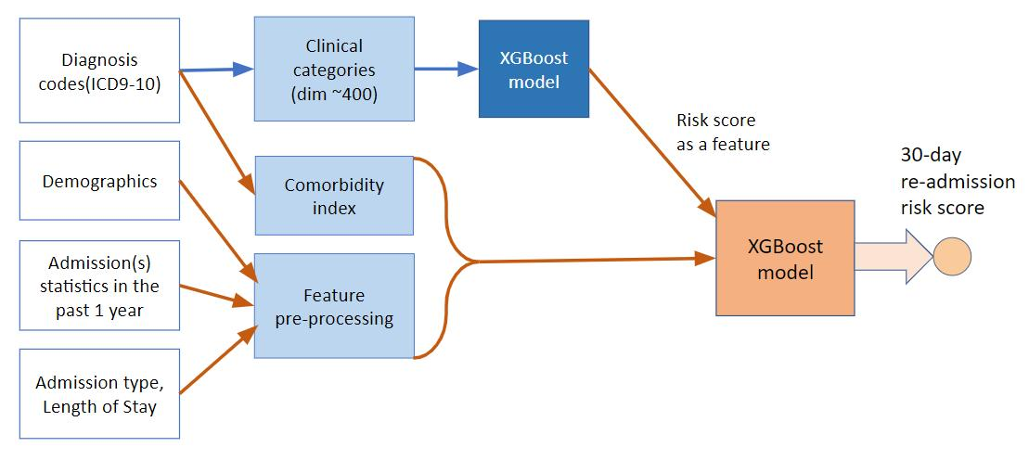
Working process:
- Collect patient information.
- Preprocess the dataset.
- Handle missing values.
- Balance the training data.
- Apply the classification model.
- Calculate readmission risk.
- Generate alerts.
- Display explanations to doctors.
7.5 Data preprocessing
Handling missing values:
- Numerical values: Median imputation.
- Categorical values: Mode or Unknown category.
- Add missing-value indicators where useful.
Handling imbalance:
Since only 6% of patients are readmitted, the dataset is highly imbalanced.
Possible techniques:
- Class weighting.
- Random oversampling.
- Random undersampling.
- SMOTE applied only to training folds.
Feature selection:
Select important attributes such as previous admissions, length of stay, age and diagnosis group.
Remove patient identifiers and irrelevant attributes.
7.6 Classification technique
A cost-sensitive decision tree is selected.
Reasons:
- Easy to understand.
- Supports numerical and categorical attributes.
- Provides clear decision paths.
- Supports classification of high-risk patients.
- Helps doctors understand alerts.
The model should be pruned to avoid overfitting.
7.7 Evaluation measures
The following measures should be used:
- Recall
- Precision
- ROC-AUC
- PR-AUC
- Confusion matrix
- Total classification cost
Recall is particularly important because missing a high-risk patient is costly.
7.8 Stage 4 – Analytical validation
False negative cost = 10.
False positive cost = 1.
Formula:
\[ Total\ Cost=10(FN)+FP \]
Consider two illustrative decision thresholds:
Measure | Threshold A | Threshold B
TP | 50 | 58
FN | 10 | 2
FP | 100 | 300
TN | 840 | 640
Threshold A:
\[ Cost=10(10)+100 \]
\[ \boxed{Cost=200} \]
Threshold B:
\[ Cost=10(2)+300 \]
\[ \boxed{Cost=320} \]
Therefore, Threshold A has the lower total cost in this example.
Preferred: Threshold A
These are hypothetical confusion matrices for demonstrating the calculation, not actual hospital experiment results.
7.9 Why is accuracy inappropriate?
Only 6% of patients are readmitted.
If the classifier predicts every patient as not readmitted:
\[ Accuracy=94\% \]
However, it fails to identify all readmitted patients.
Therefore, accuracy cannot be used as the only evaluation measure.
7.10 Strengths and limitations of the selected model
Strengths:
- Easy to interpret.
- Provides understandable decision paths.
- Handles classification problems.
- Can incorporate class weights.
- Supports clinical decision-making.
Limitations:
- May overfit.
- Can be sensitive to small data changes.
- May not capture complex relationships.
- Missing values can affect results.
- Requires regular validation.
7.11 Stage 4 – Experimental validation
Student B must implement the proposed model using Weka or Python on a suitable public medical dataset.
Suggested procedure:
- Obtain a public hospital readmission or imbalanced medical dataset.
- Preprocess missing values.
- Apply stratified cross-validation.
- Implement a baseline classifier.
- Implement the cost-sensitive decision tree.
- Compare performance.
- Record recall, precision, ROC-AUC and total cost.
Experiment comparison:
Model | Recall | Precision | ROC-AUC | Total cost
Baseline | To be measured | To be measured | To be measured | To be measured
Cost-sensitive tree | To be measured | To be measured | To be measured | To be measured
Tree with resampling | To be measured | To be measured | To be measured | To be measured
The final report should include actual results from the selected dataset.
7.12 Stage 5 – Cross-defence
Student A: What experimental evidence supports the group's design?
The evidence includes cross-validation results, recall, precision, ROC-AUC, confusion matrices and total classification cost. The cost-sensitive tree should be compared against the baseline using the same validation folds.
Student B: How is the cost ratio derived?
The problem states that missing a high-risk patient costs ten times more than flagging a patient incorrectly.
Therefore:
\[ Cost(FN):Cost(FP)=10:1 \]
The total cost is calculated using:
\[ 10(FN)+FP \]
The threshold is selected using validation data to minimise this cost while maintaining acceptable clinical recall.
7.13 Stage 6 – Joint evaluation
Why is the problem difficult?
- Readmission cases are rare.
- The dataset contains missing values.
- False negatives are expensive.
- Patient information may be complex.
- Doctors require understandable explanations.
What is sacrificed to improve interpretability?
A simpler tree may sacrifice some predictive accuracy compared with a complex machine-learning model.
Under what conditions can the model fail?
- Incorrect patient information.
- Excessive missing values.
- Changes in patient population.
- Poor-quality training data.
- New medical conditions not represented in training data.
7.14 Final conclusion
Before selecting a classifier, a data miner should examine:
- Dataset size.
- Number and type of attributes.
- Missing values.
- Class distribution.
- Cost of classification errors.
- Required interpretability.
- Computational requirements.
- Data quality and privacy.
- Model accuracy and reliability.
- Real-world application requirements.
Overall conclusion: A cost-sensitive decision tree is a suitable choice for hospital readmission prediction because it balances classification performance, error costs and interpretability.
Contribution Record
Complete this table according to the actual work performed by both students.
Question | Student A | Student B | Joint work
Q1 | Entropy and decision tree | Weka J48 | Tree comparison
Q2 | Probability calculations | Weka Naïve Bayes | Bayesian analysis
Q3 | Rule extraction | JRip/PART | Rule comparison
Q4 | Backpropagation calculations | MLP implementation | Performance analysis
Q5 | SVM geometry | Kernel experiments | SVM evaluation
Q6 | Evaluation metrics | Cross-validation | Model comparison
Q7 | Cost calculations | Experimental validation | Final design
Overall Conclusion
Data mining plays an important role in extracting useful information and making accurate predictions from large datasets.
This assignment explains different classification techniques, including Decision Trees, Naïve Bayes, Rule-Based Classification, Backpropagation and Support Vector Machines.
It also explains classifier evaluation methods such as Accuracy, Precision, Recall, F-measure, ROC curves, Cross-validation and Bootstrap.
The hospital readmission case study demonstrates how classification techniques can be applied to real-world problems by considering class imbalance, missing values, prediction costs and interpretability.
Thus, selecting an appropriate classification algorithm depends on dataset characteristics, prediction requirements, error costs and the need for understandable results.

